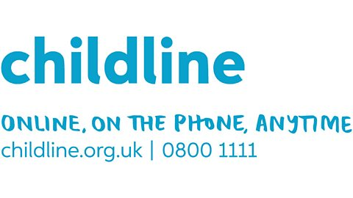

**POENI AM BLENTYN?**

**ANGEN SIARAD?**

**WORRIED ABOUT A CHILD? NEED TO TALK?**

Cysylltiadau **Cylch Meithrin Pontrobert** Contacts:

Swyddog Amddiffyn Plant / Child Protection Officer

Mrs Lowri Lewis 07572 749 925

neu / or,

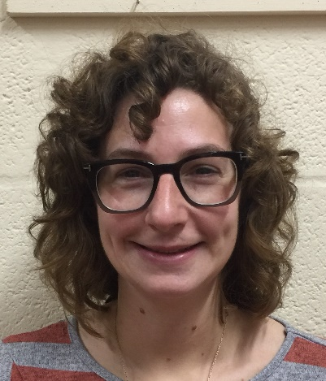Dirprwy Swyddog Amddiffyn Plant / Deputy Child Protection Officer

Mrs Siwan Jones 07964 746 040

neu / or,

Cysylltwch â Llinell Uniongyrchol / Contact Powys People direct on 01597 827 666

Mae diogelu plant a phobl ifanc yn gyfrifoldeb pawb. Safeguarding children and young people is

everybody’s responsibility.